Micro Project

ONLINE AUCTION SYSTEM

Ashwin Kumar Maheswaran

ID: 11993

Project Description:

**Case Study 10: Online Auction Site**

It’s an online website aimed at carrying out auctions. The slogan of this website is AAA standing for ‘Anytime, Anyone, anywhere’. This is like an auction house provided online where the users can take part from the Comfort of their homes. Also, the registered users can place products for bidding.

Features:

→ Users can register and add the products they want to sell

→ Users can register and view the products under auction

→ Users can place bid requests

→ Users can track their bid status and existing bid prices

→ Users can search, generate reports on their bids

W3H Analysis:

|  |  |
| --- | --- |
| **What** | **How** |
| **What are the modules to be included**   1. **User registration and login module** 2. **Product listing module** 3. Adding products 4. Listing products 5. **Bidding module** 6. Listing existing bid prices 7. Placing bid request 8. **Bid tracking module** 9. Bid history 10. Notification 11. **Search module** 12. **Report module** | 1. **User registration module**   Solution 1: The user can register through email and password and submit the necessary documents. Login through email and password.  Solution 2: User can register through social media account and submit the necessary document. Use the same account to login   1. **Product listing module** 2. **Adding products**   Solution 1: User can add products by filling a form with the product details.  Solution 2: User can be provided with the interface for adding the product details.   1. **Listing Products**   Solution 1: User can view the products on the homepage or search for a particular product. This can be done with or without login.  Solution 2: The products can be listed only when the user wants to bid on a product.   1. **Bidding module** 2. **Listing existing bid prices**   Solution 1: The bid price and the bidder's name of every user can be displayed on the product page.  Solution 2: Only the highest price and the bidder’s name can be displayed.  Solution 3: Only the highest price can be displayed on the product page without the bidder's name.   1. **Placing bid request**   Solution 1: First the bid request will be sent to the admin for a particular product. After approval for the request, the user can place the bidding amount.  Solution 2: User can directly place their bidding amount without any request approval.   1. **Bid tracking module** 2. **Bid history**   Solution 1: The user can view their history of bidding and selling on different pages.  Solution 2: The user can view their history of bidding and selling on the same page.   1. **Notification**   Solution 1: The notification can be sent to mobile number, email and to the website account.  Solution 2: The notification can be sent to the website account. It can be viewed only after login.     1. **Search module**   Solution 1: The user can search the products through product description and using filtering option.  Solution 2: The user can search for products by name of product or seller.   1. **Report module**   Solution 1: Admin will generate reports for bidding and selling of the user. The user can view the report from their dashboard.  Solution 2: The user can request a report and the admin will generate and send it through email. |
| **Why** | **Why Not** |
| 1. Solution 1: The user can register through email and password and submit the necessary documents.   This solution is the easiest way for a user to register by giving their desired email    2. Solution 2: User can be provided with the interface for adding the product details.   Giving a customizable interface will be helpful for the users to add their products and their image or video.   1. Solution 1: User can view the products on the homepage or search for a particular product. This can be done with or without login.   This will be helpful for the users to surf the website without login.    2. Solution 3: Only the highest price can be displayed on the product page without the bidder's name.   The highest price is the only necessary detail which the bidder needs to know.   1. Solution 2: User can directly place their bidding amount without any request approval.   This is the easiest way to place a bid on a particular product.    2. Solution 2: The user can view their history of bidding and selling on the same page.   This will be helpful for the user to view all their history without navigating to other pages.   1. Solution 1: The notification can be sent to mobile number, email and to the website account.   By applying this solution, the user can be notified from anywhere.   1. Solution 1: The user can search the products through product description and using filtering option.   This will be helpful for the user to search for a product easily.   1. Solution 1: Admin will generate reports for bidding and selling of the user. The user can view the report from their dashboard.   By applying this solution, the user can view their report anytime they want. | 1. Solution 2: User can register through social media accounts and submit the necessary documents.   Social media accounts are not safe to use. Also, the user might hesitate to use it.    2. Solution 1: User can add products by filling a form with the product details.   Using the form for adding product will not look good from the user perspective.   1. Solution 2: The products can be listed only when the user wants to bid.   The user who wants to surf the site without bidding cannot be able to do it.    2. Solution 1: The bid price and the bidder's name of every user can be displayed on the product page. Solution 2: Only the highest price and the bidder’s name can be displayed.   Both these solutions will mention the highest bidder’s name, which is unnecessary in that place.   1. Solution 1: First the bid request will be sent to the admin for a particular product. After approval for the request, the user can place the bidding amount.   This is a double work where the bidder must wait for bidding.    2. Solution 1: The user can view their history of bidding and selling on different pages.   This is double work where they must move from one page to another to view their history.   1. Solution 2: The notification can be sent to the website account. It can be viewed only after login.   This solution is not efficient because the user might miss seeing the notification.   1. Solution 2: The user can search for products by name of product or seller.   This gives limited options for the user to search for a particular product.   1. Solution 2: The user can request a report and the admin will generate and send it through email.   Here, the user must wait to view the report. |

**UML Diagrams**

**Use case diagram:**

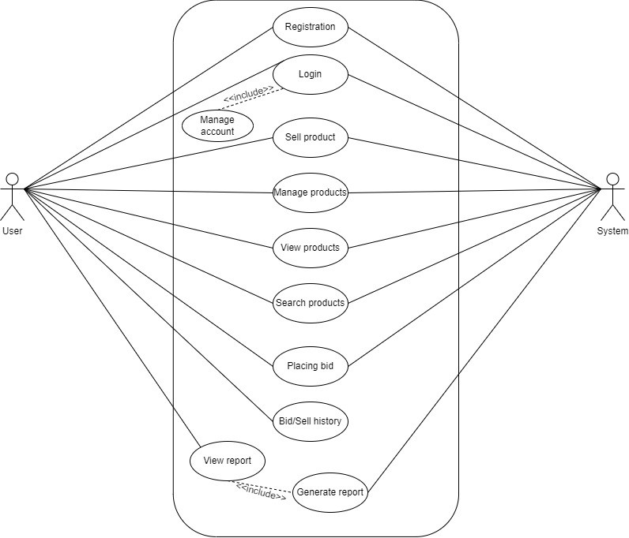

**Class diagram:**

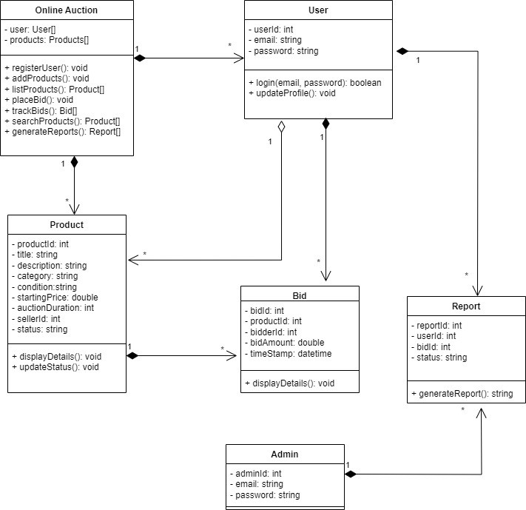

**Sequence diagram:**

Sign up and Login

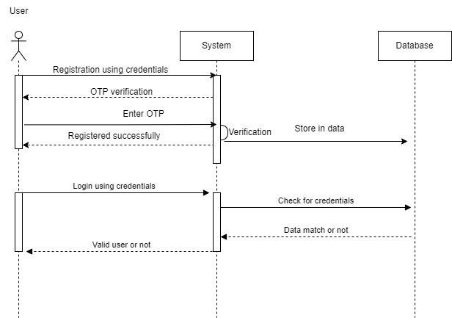

Bidding and Report

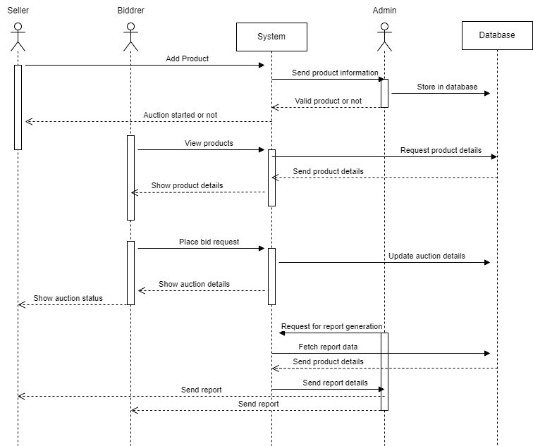

Entity Relationship Diagram

Diagram:

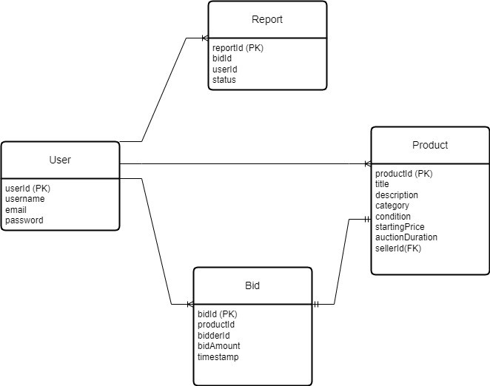

Explanation:

One User can sell many Products

One User can place many Bid

One User can have many Reports

One Bid can have only one Product

Online Auction System

UI Wireframe

Homepage:

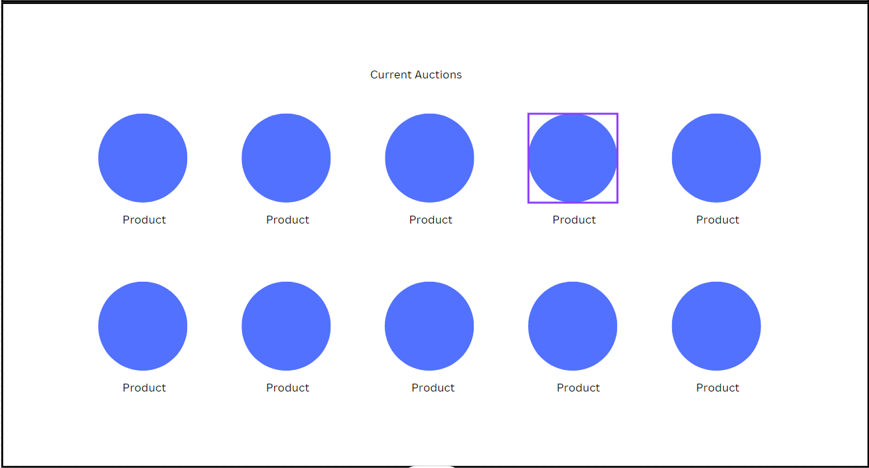

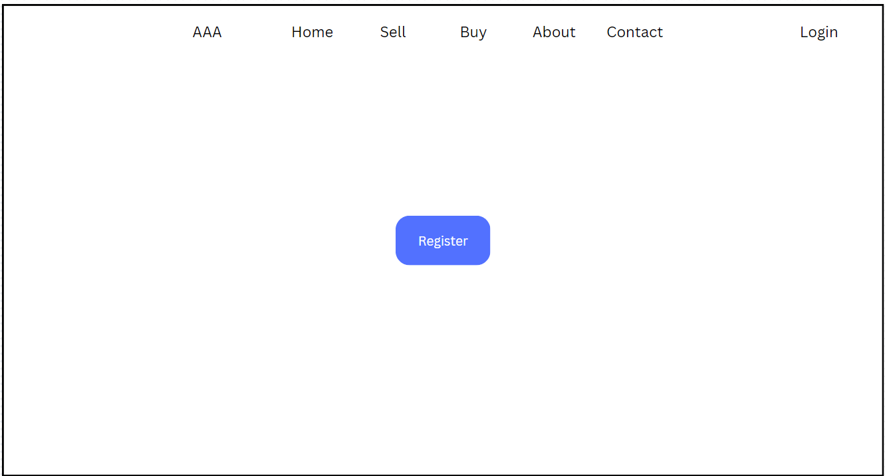

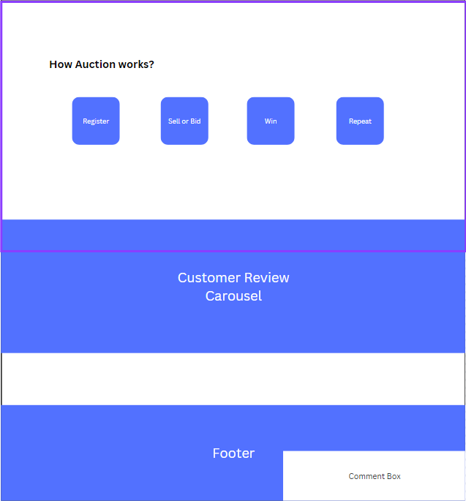

Sign up

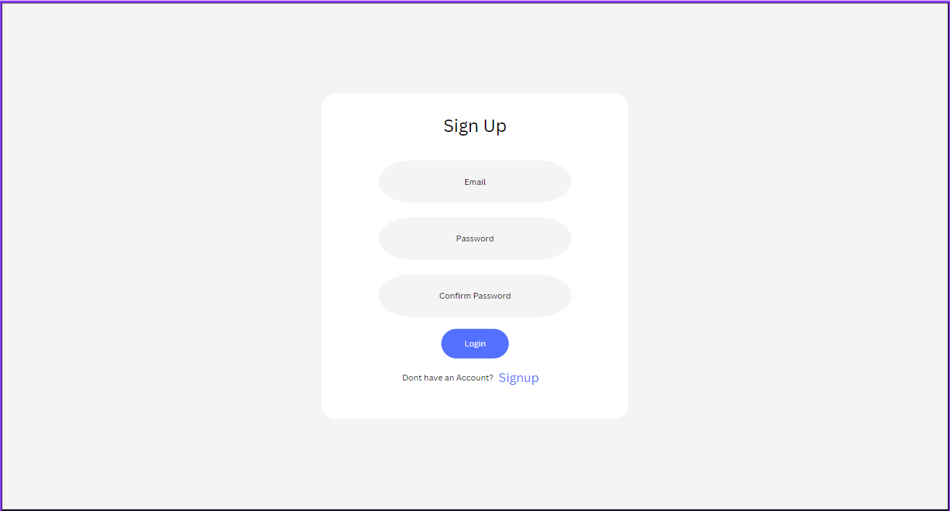

Login

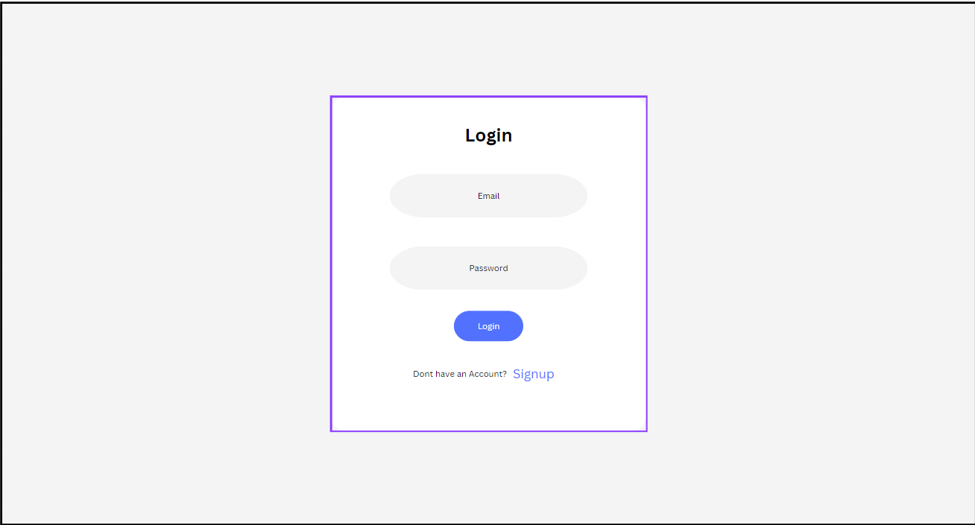

Product adding

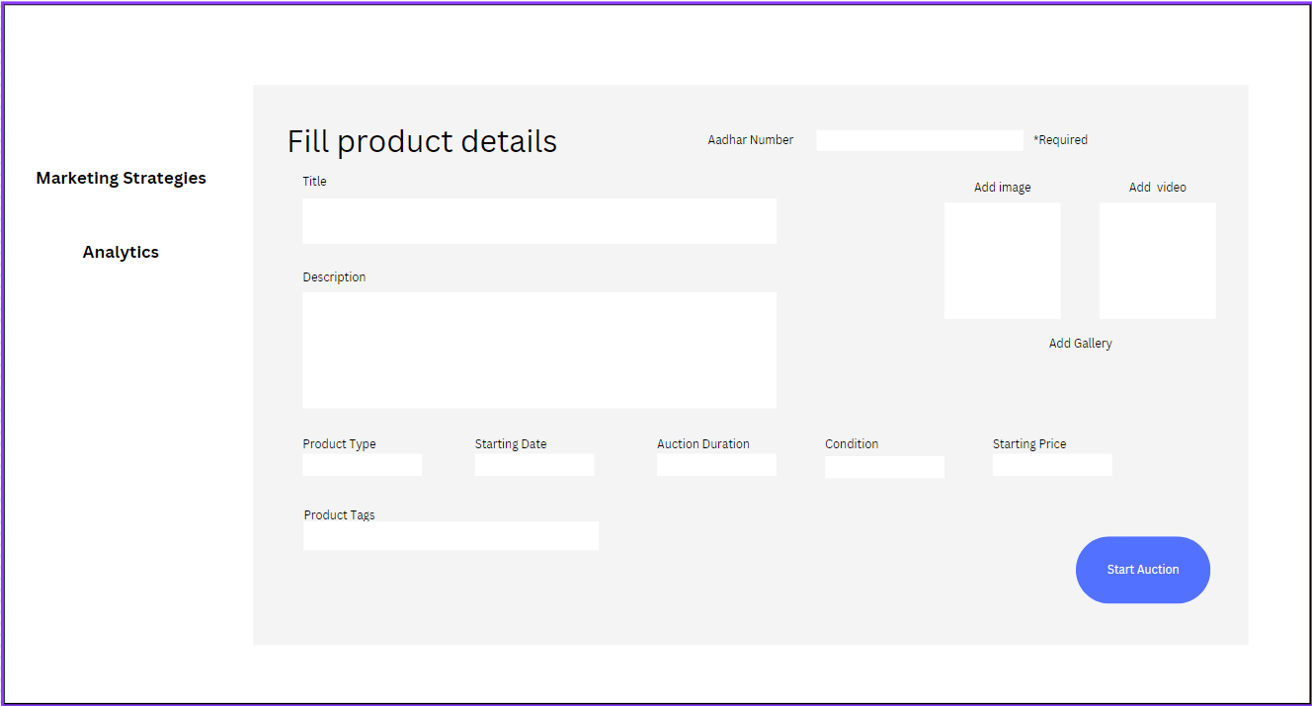

Menu bar



Bidding page

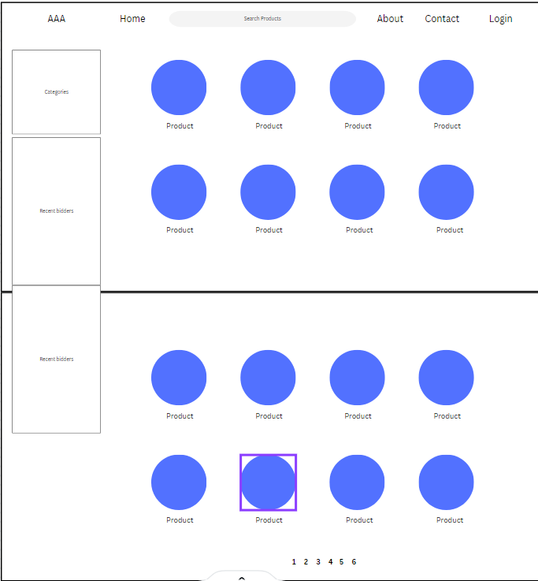

**Project Screen Shots:**

Signup Page:

Empty field Validation

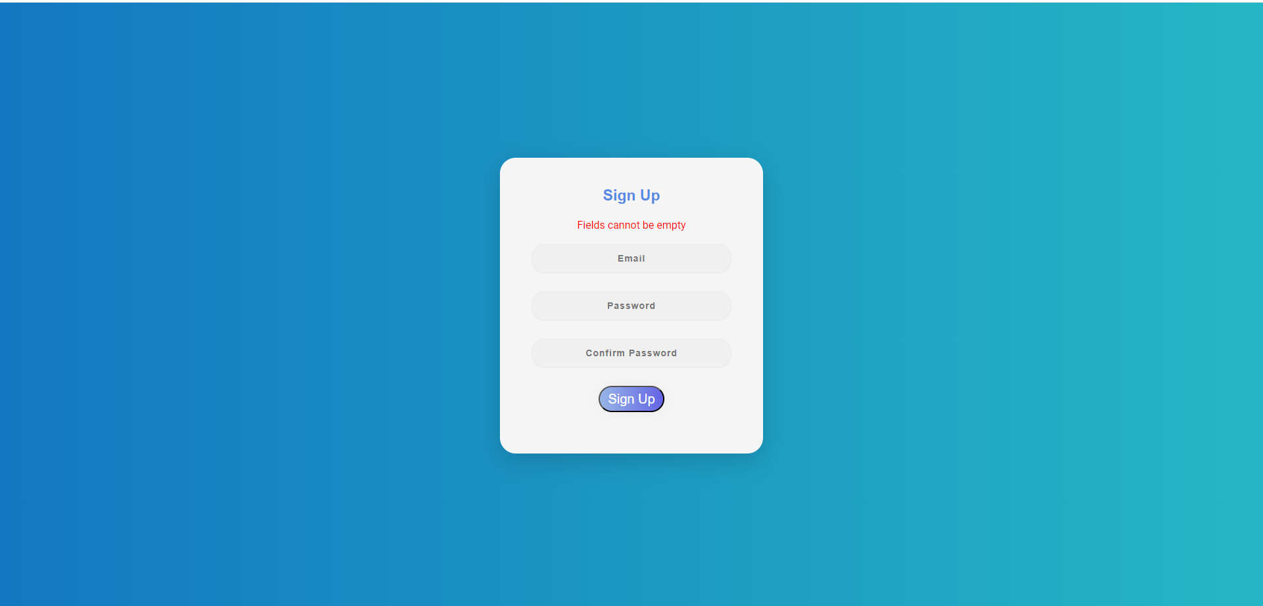

Password mismatch validation

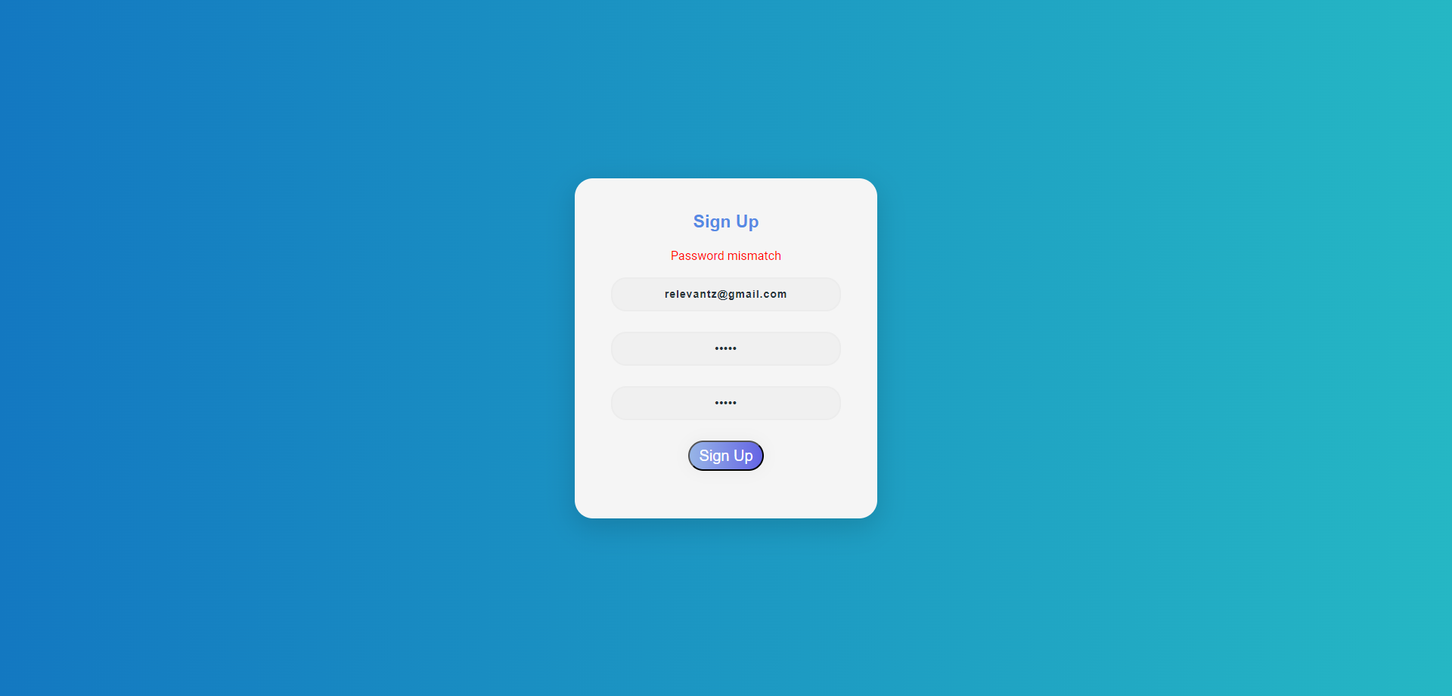

Signup success message

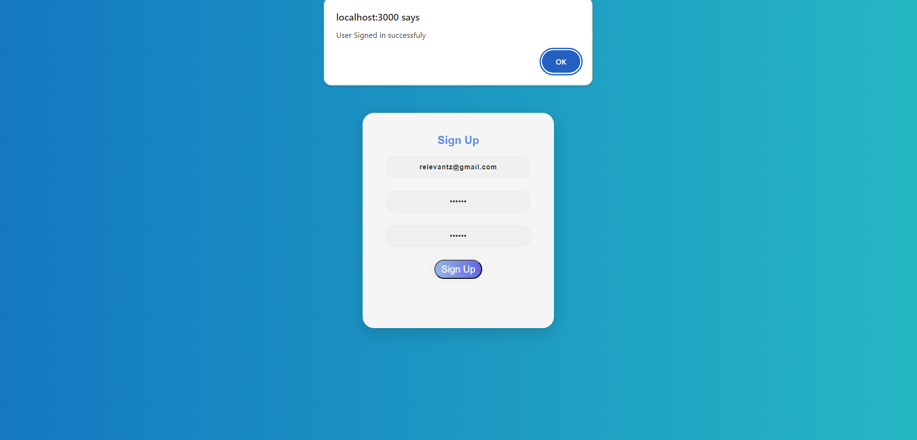

Personal details form

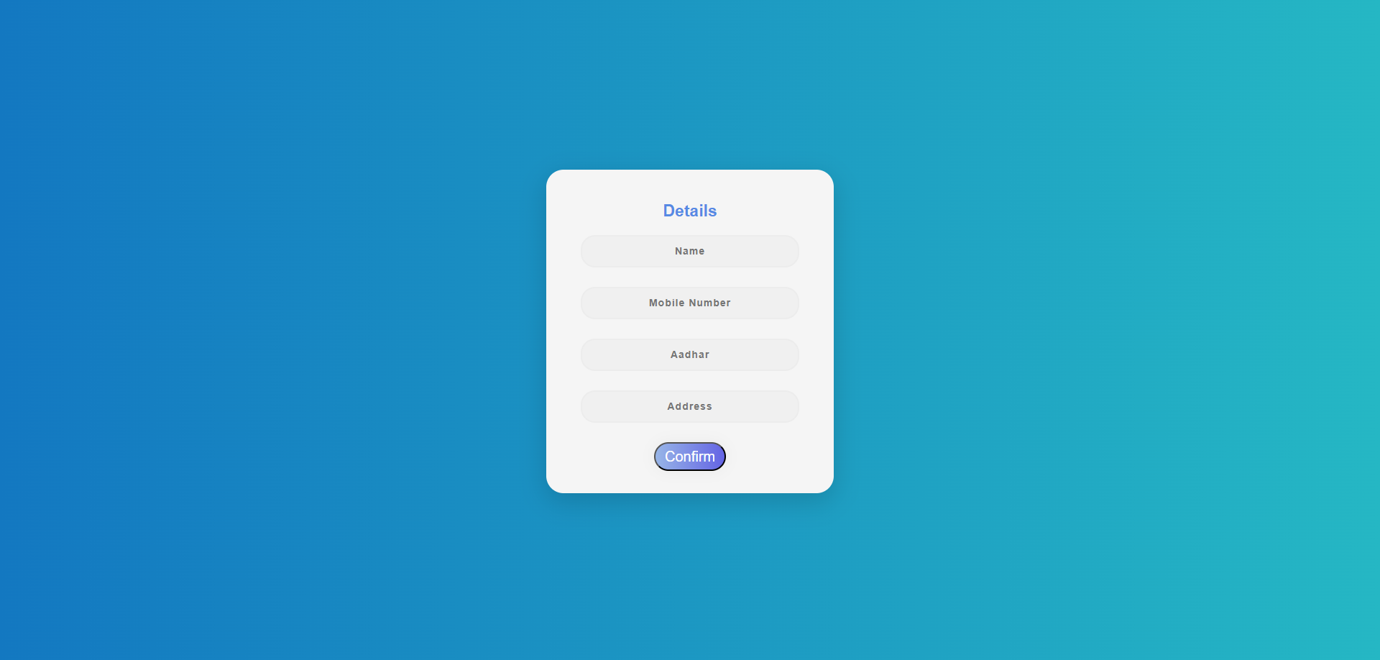

Email verification form

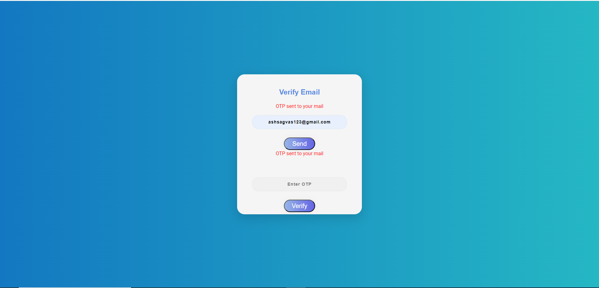

Otp in email

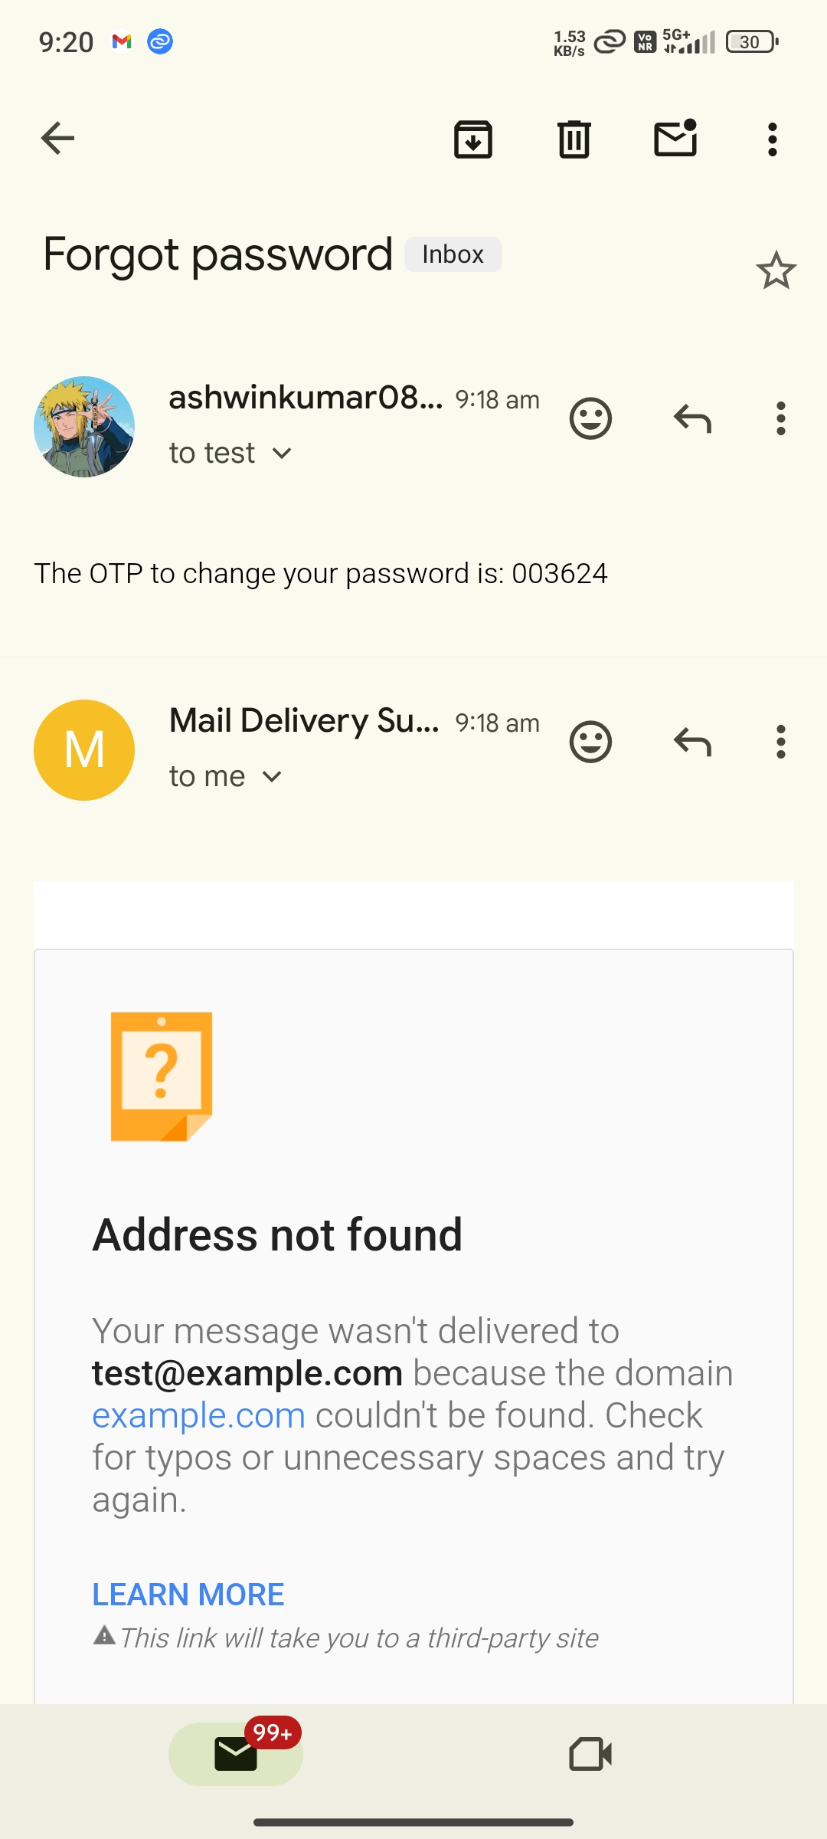

Invalid Otp

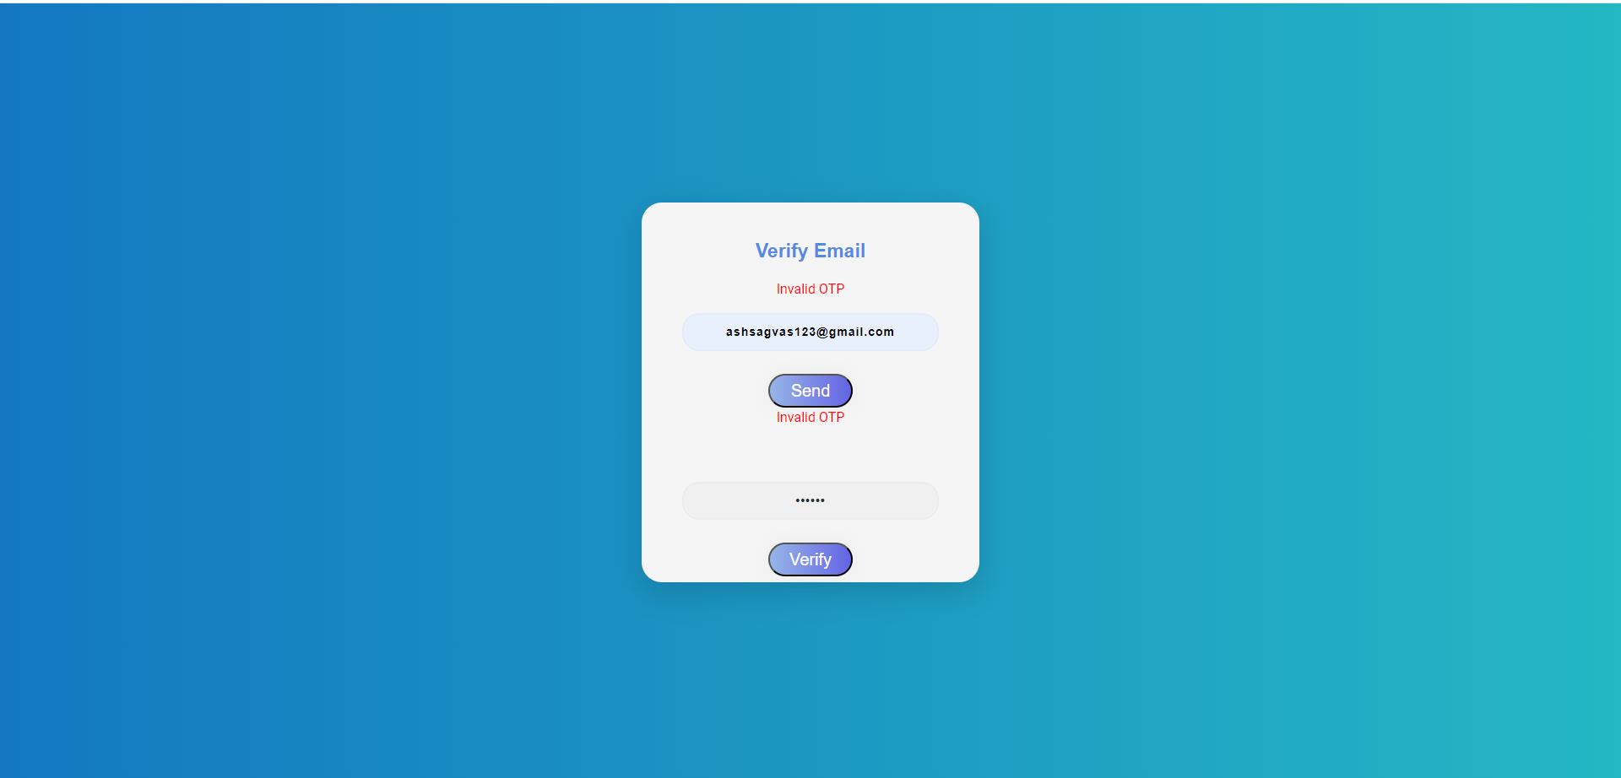

User Login

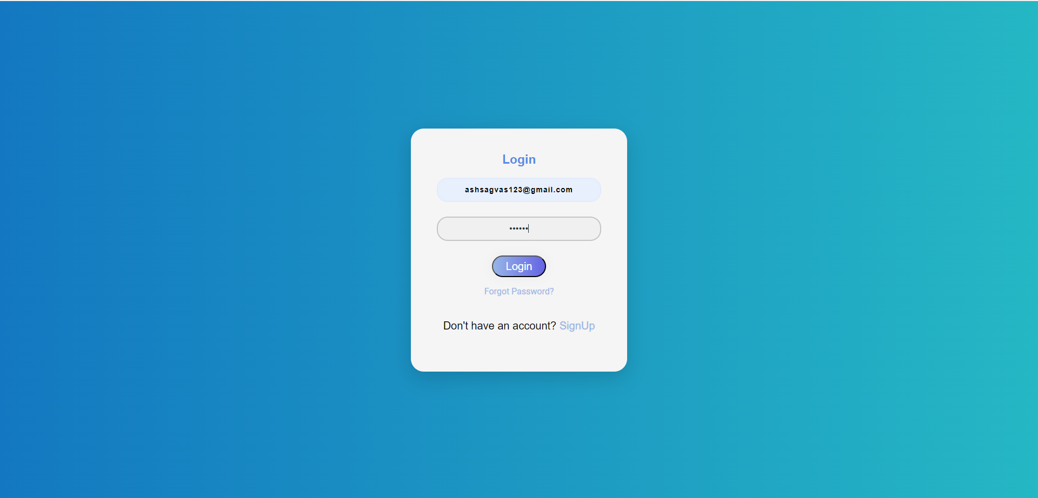

Login authentication

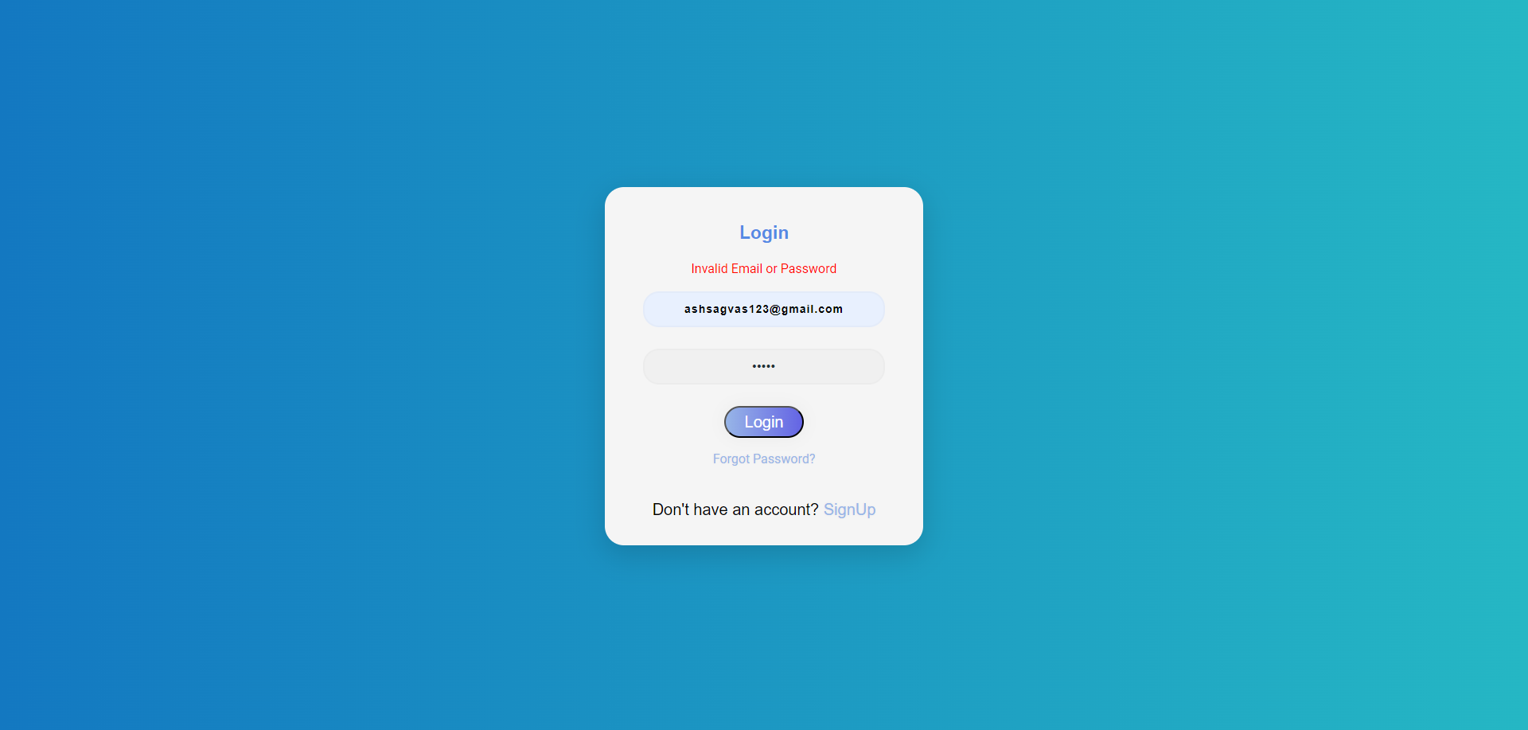

Empty field validation

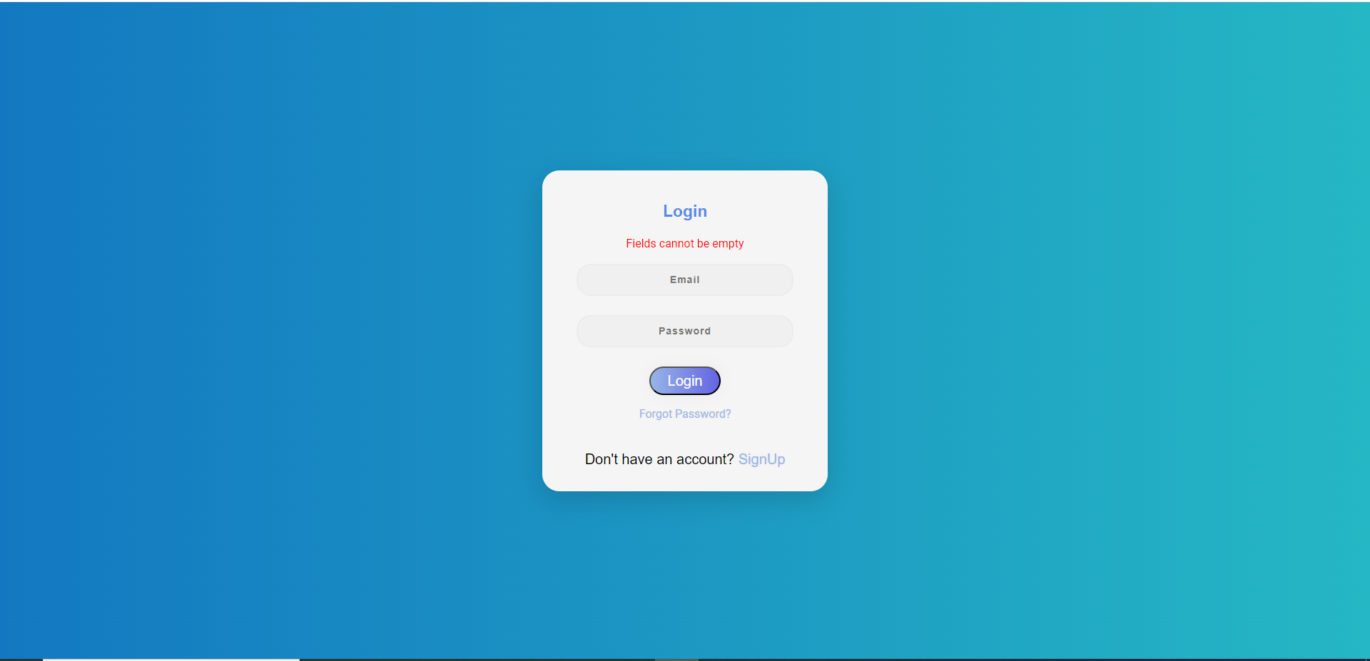

Homepage

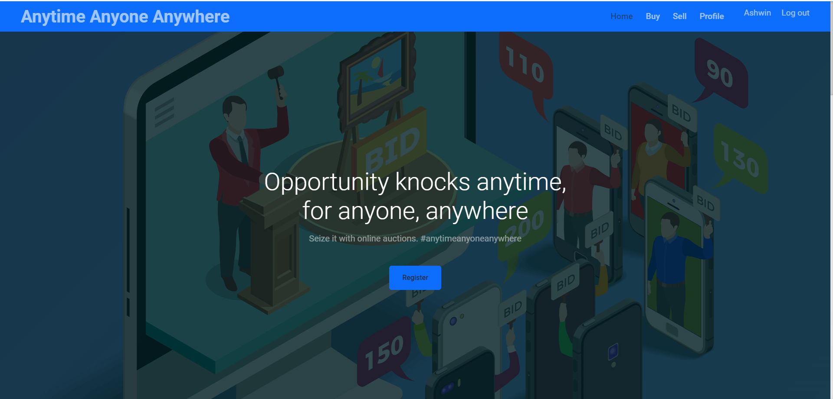

Current Auctions

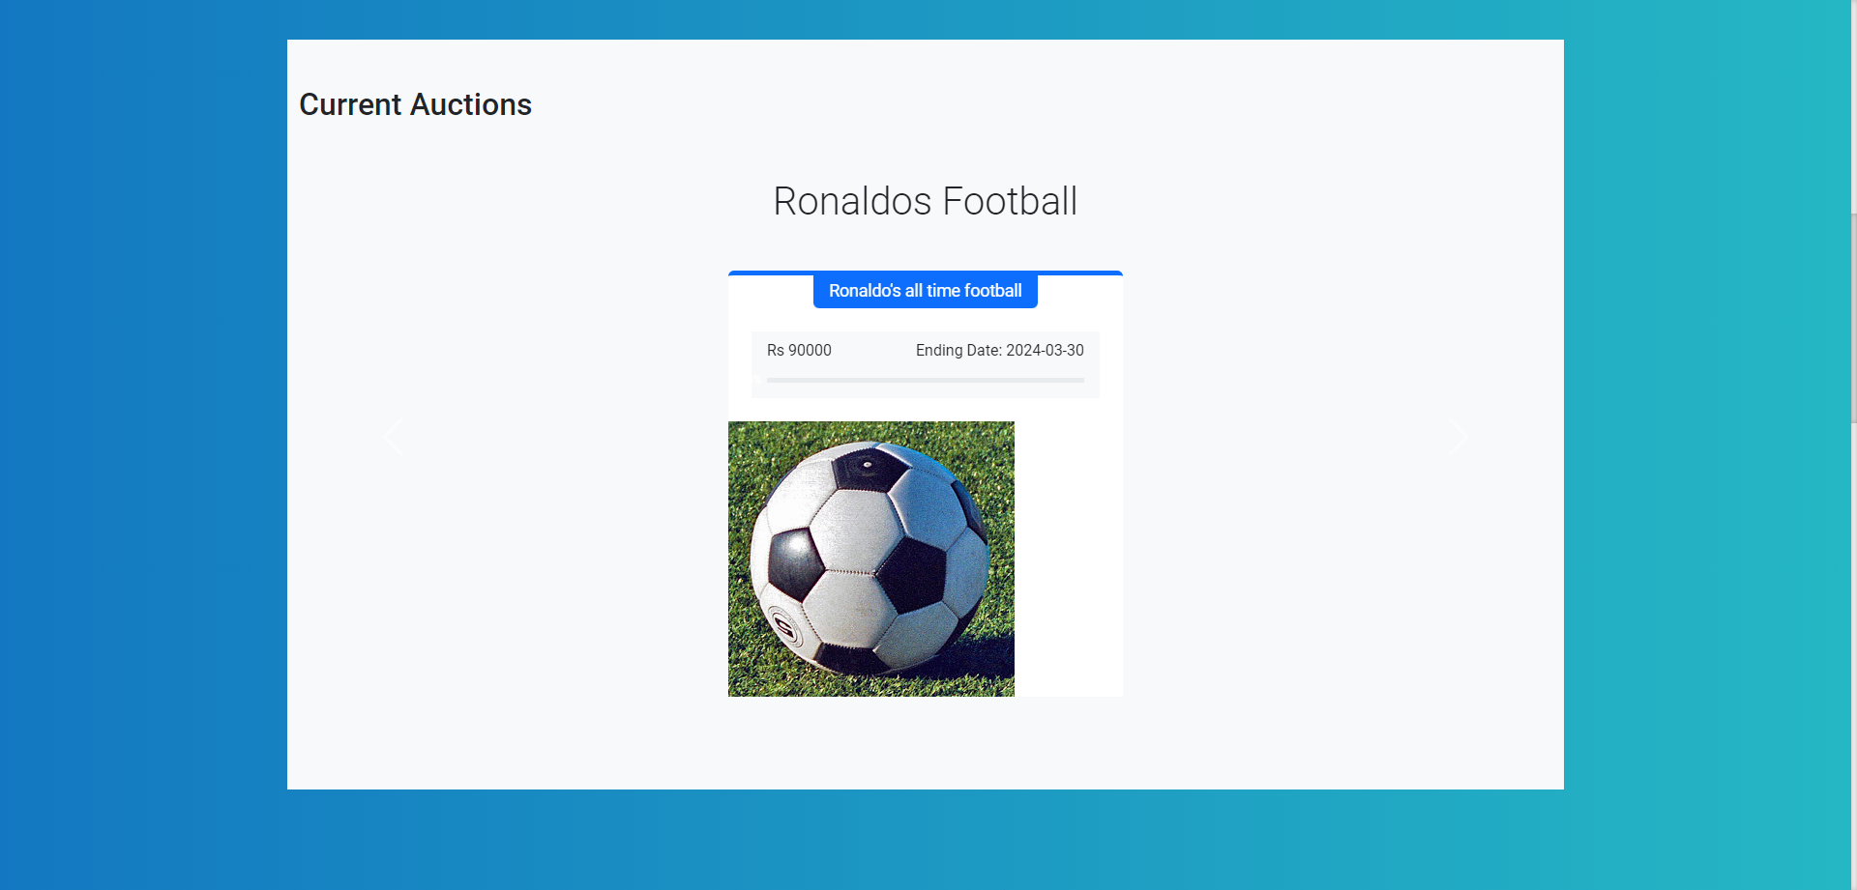

How Auction works

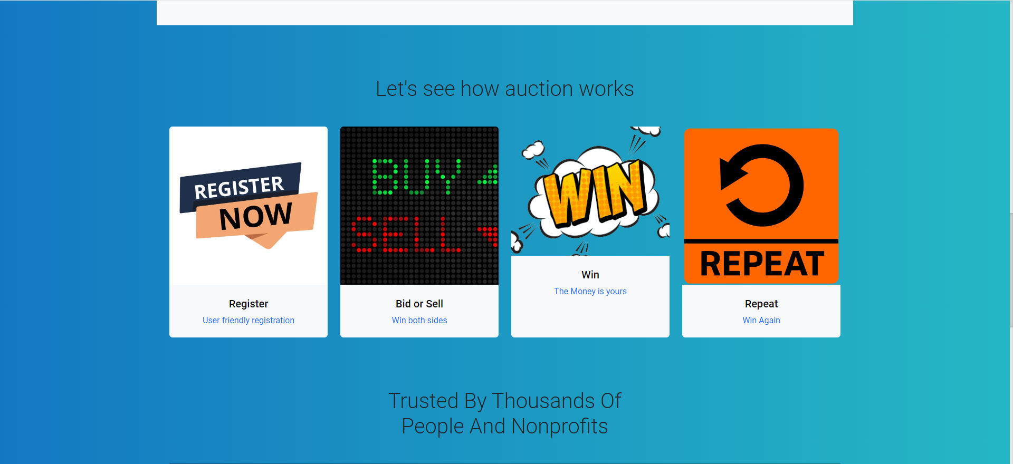

User Feedback

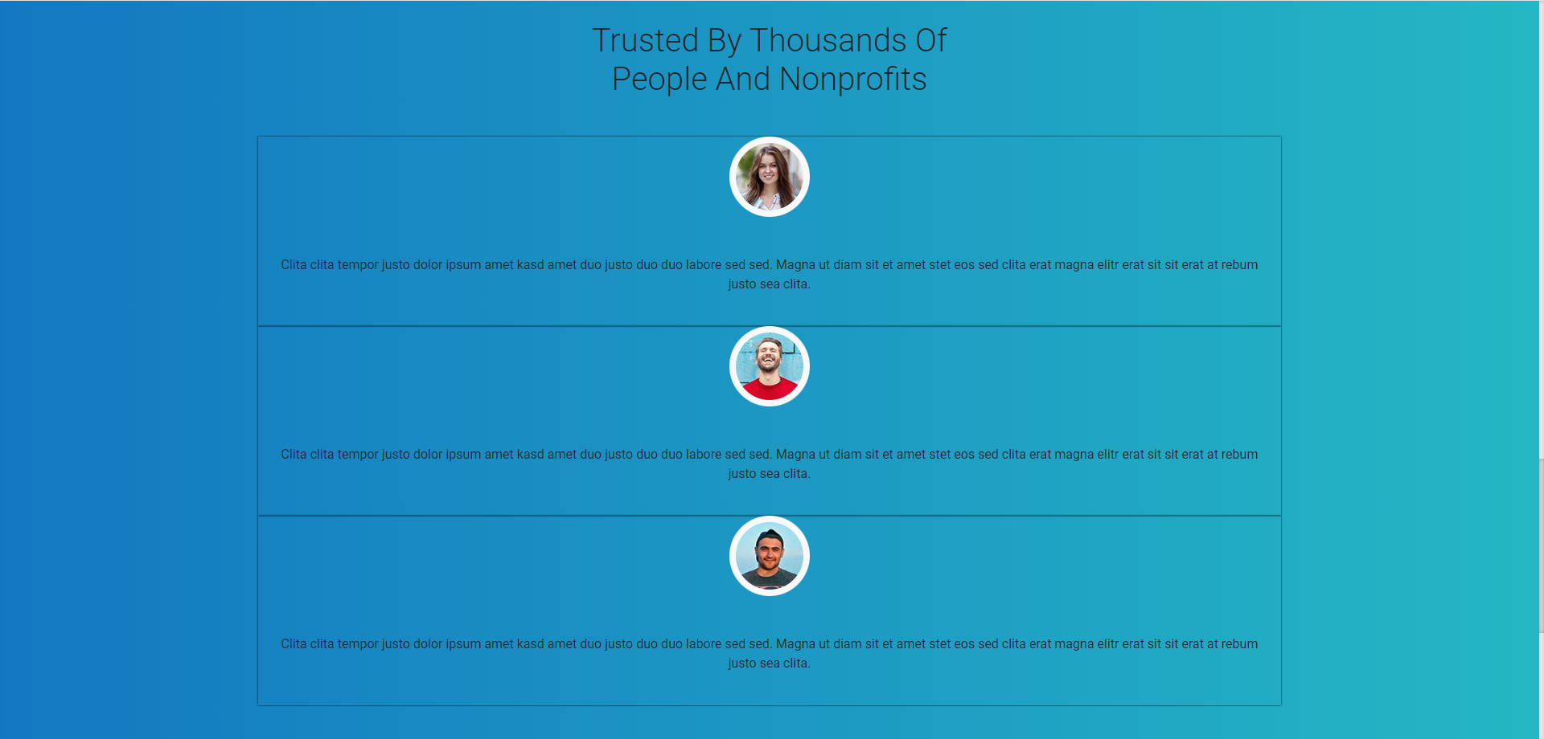

Product list

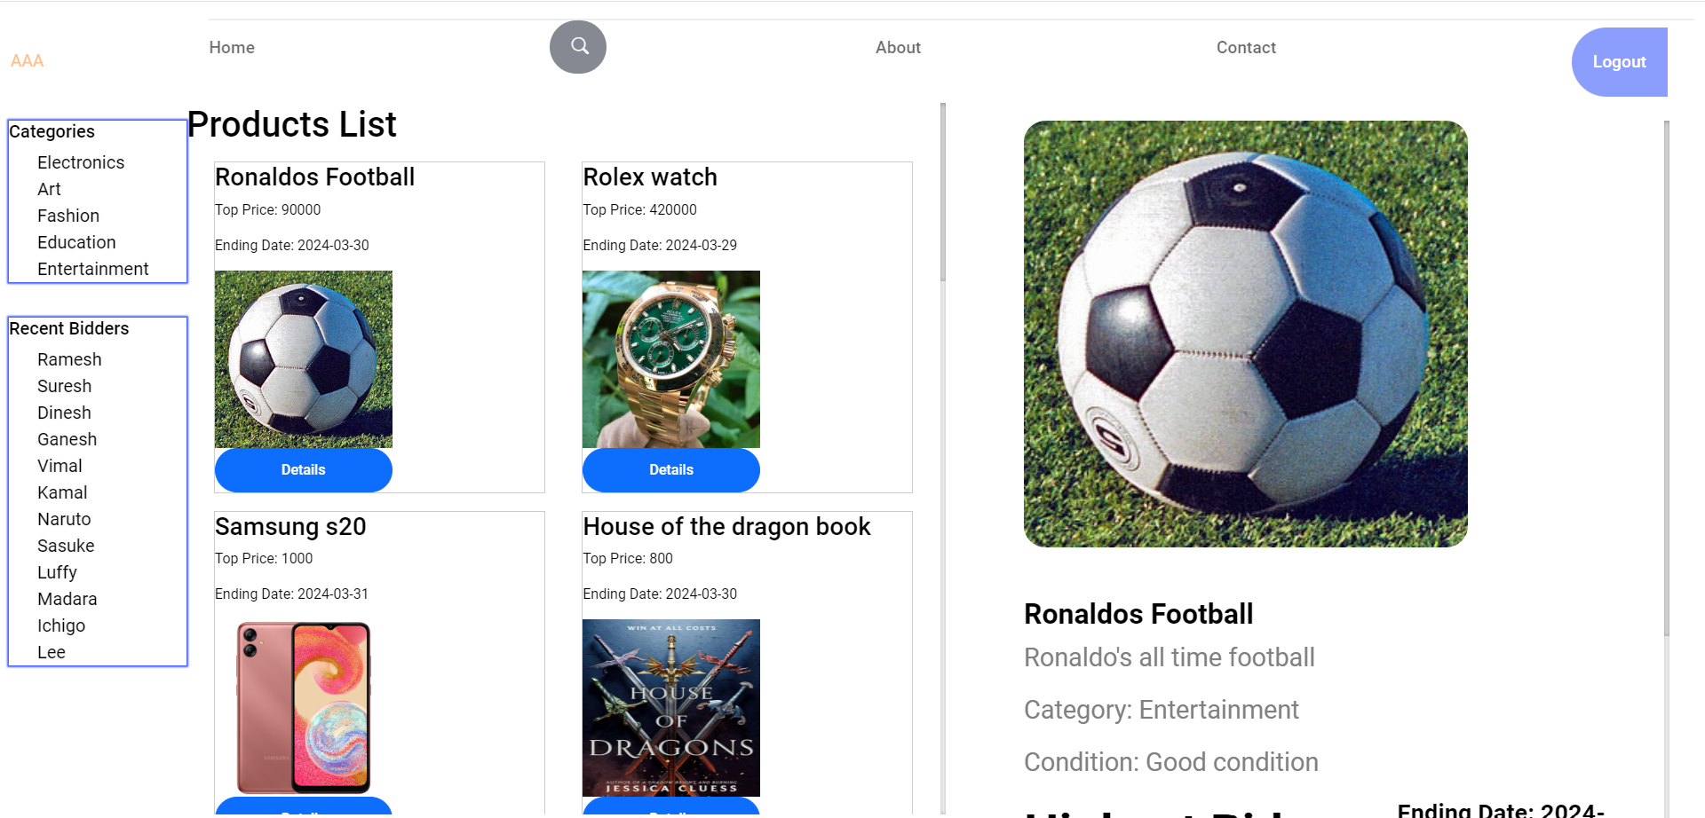

Product details

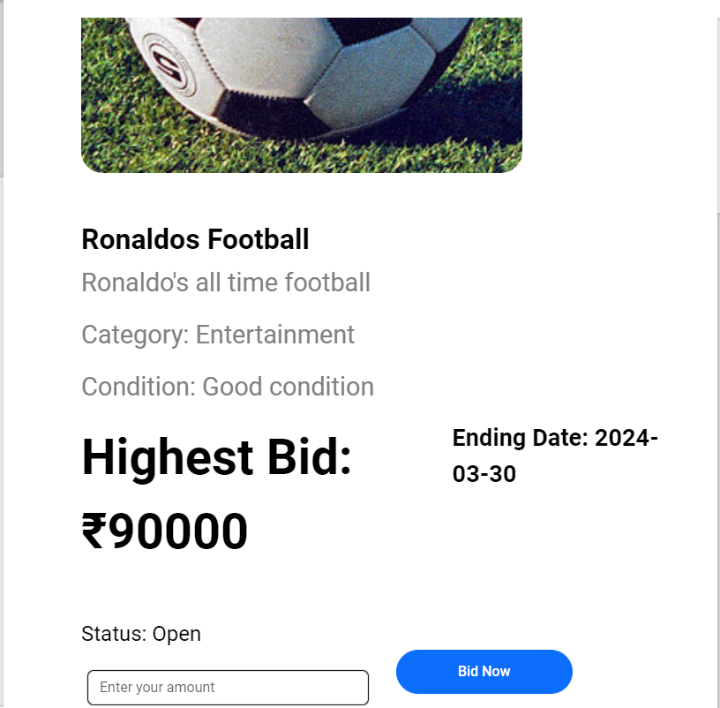

Search menu

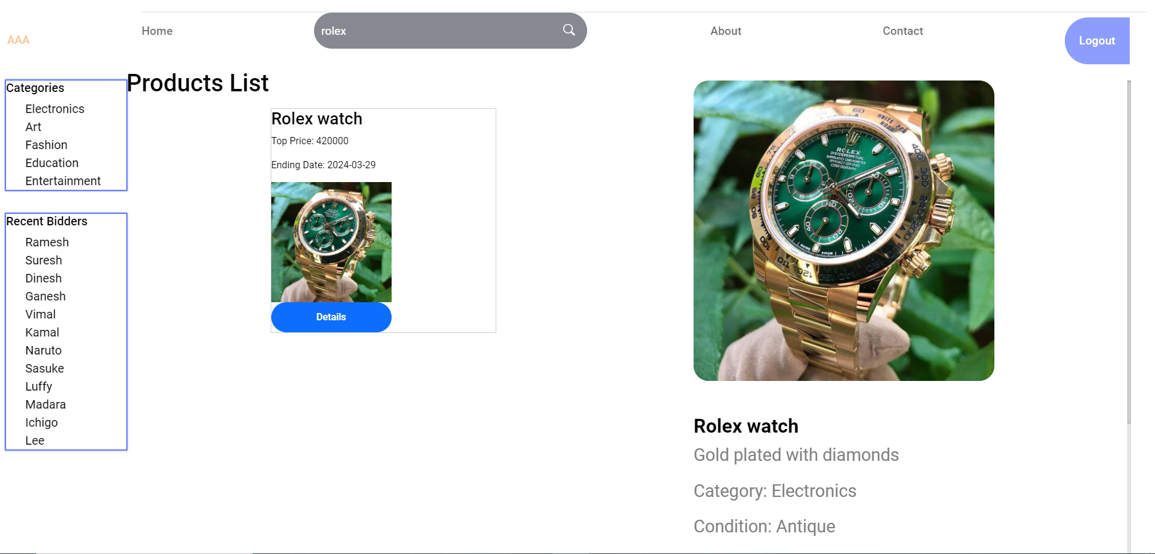

User Profile

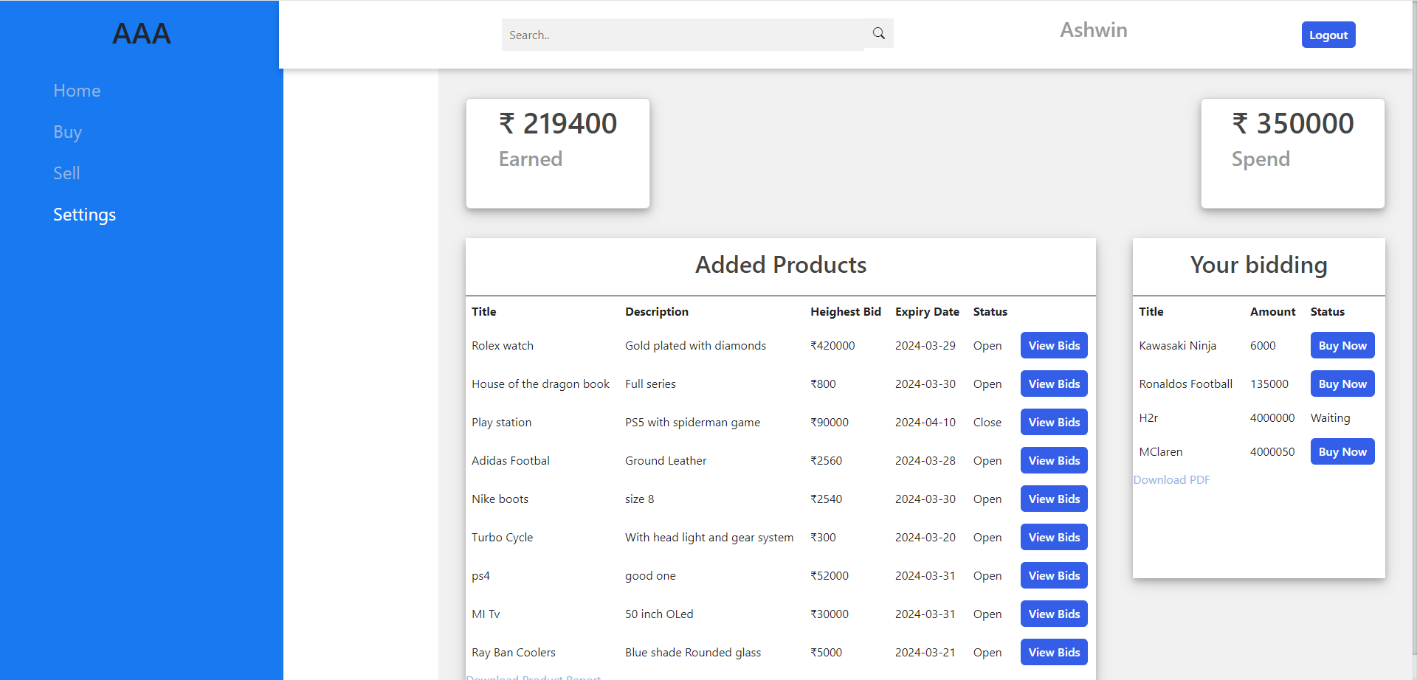

Product report

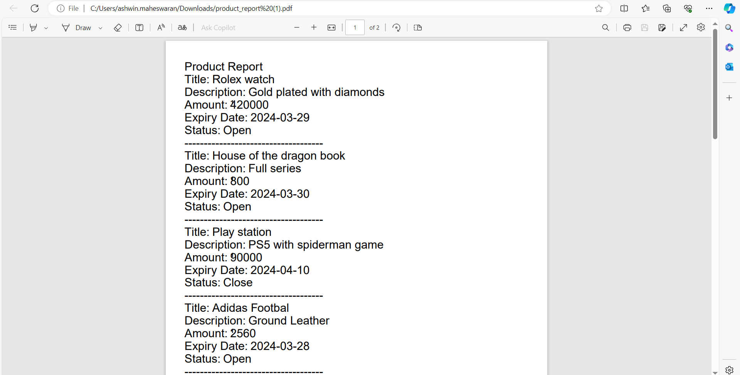

Bidding Report

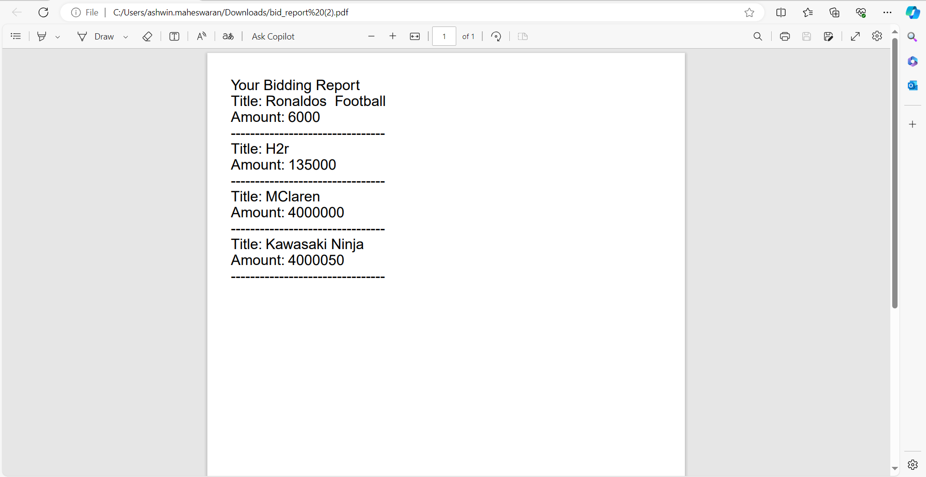

New product adding for auction

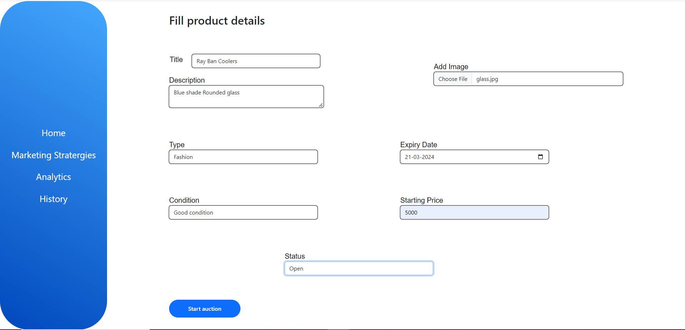

Auction started

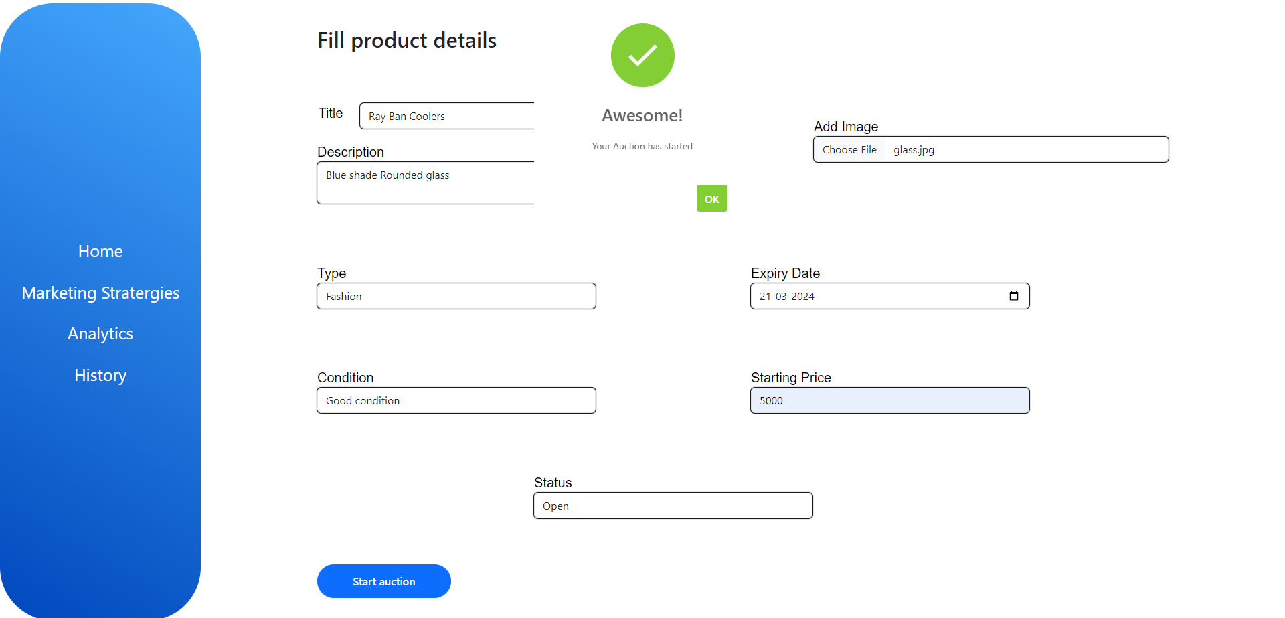

Added product

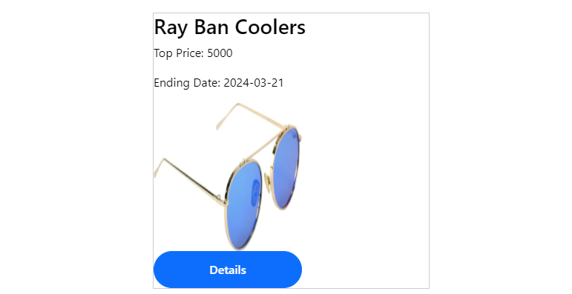

Bidding for new product

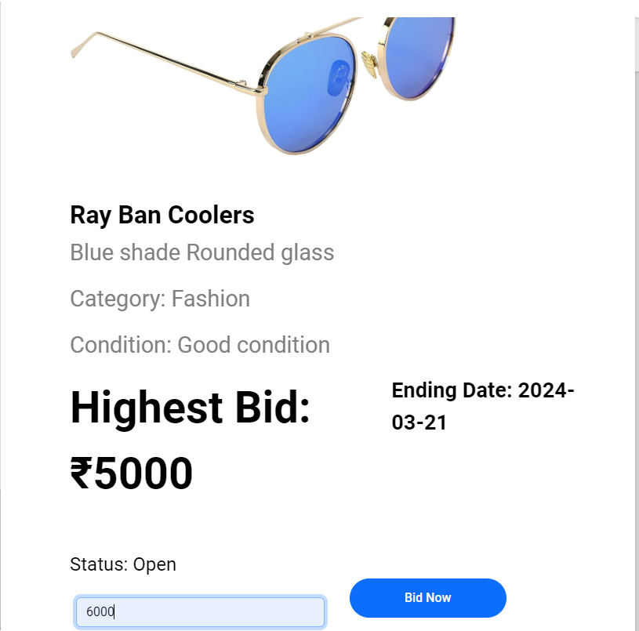

Bidding success

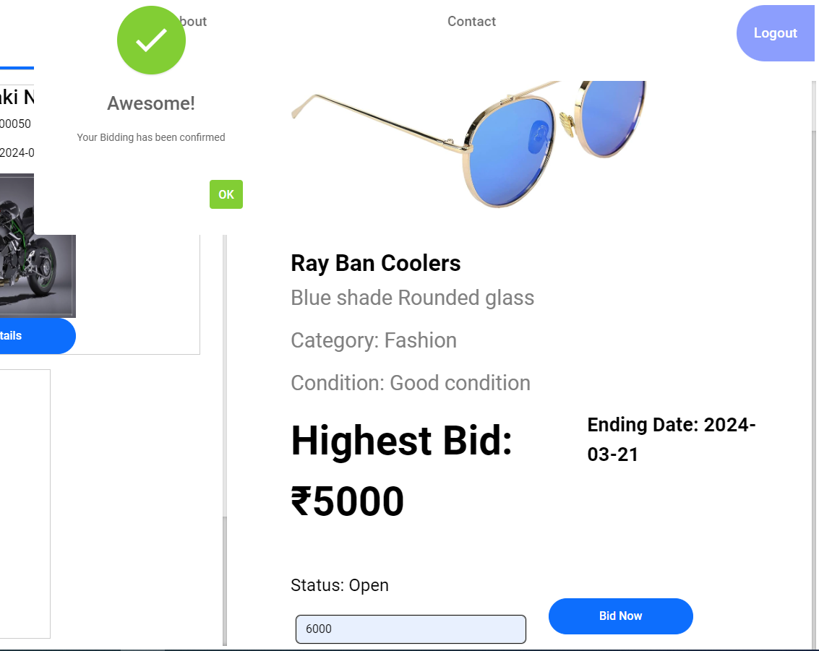

Another user bidding on the same product

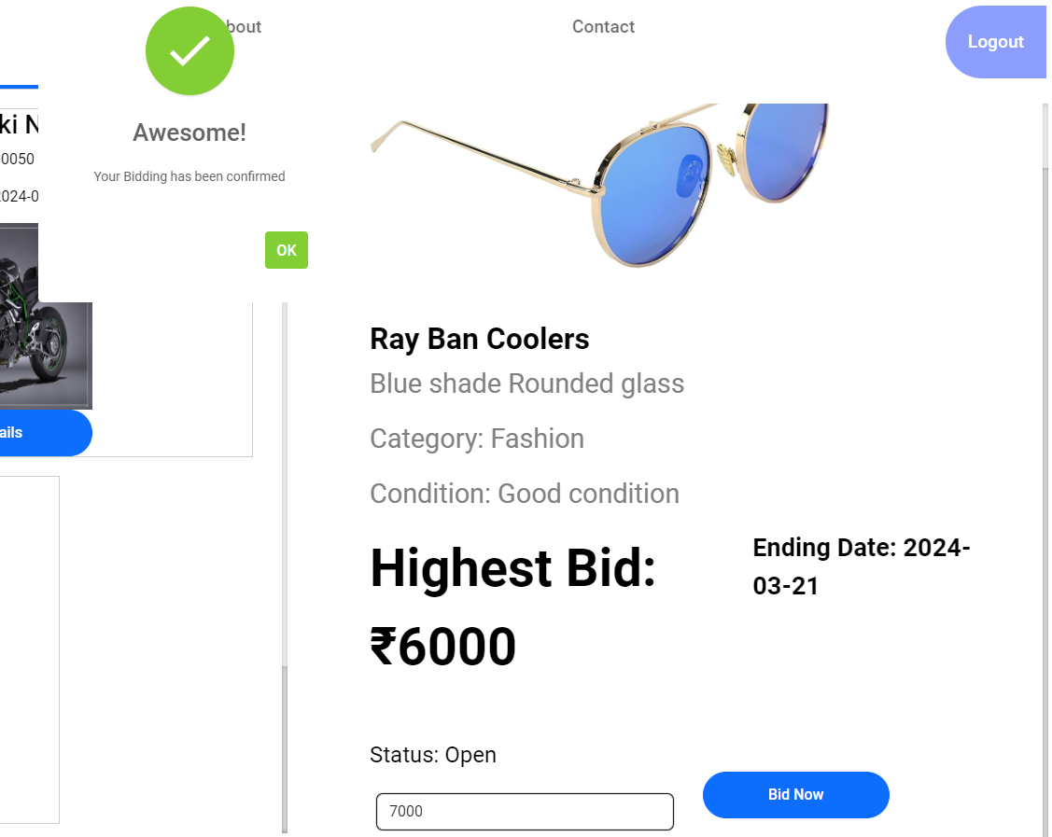

Product status before approval (Open)



View bidding list for the new product

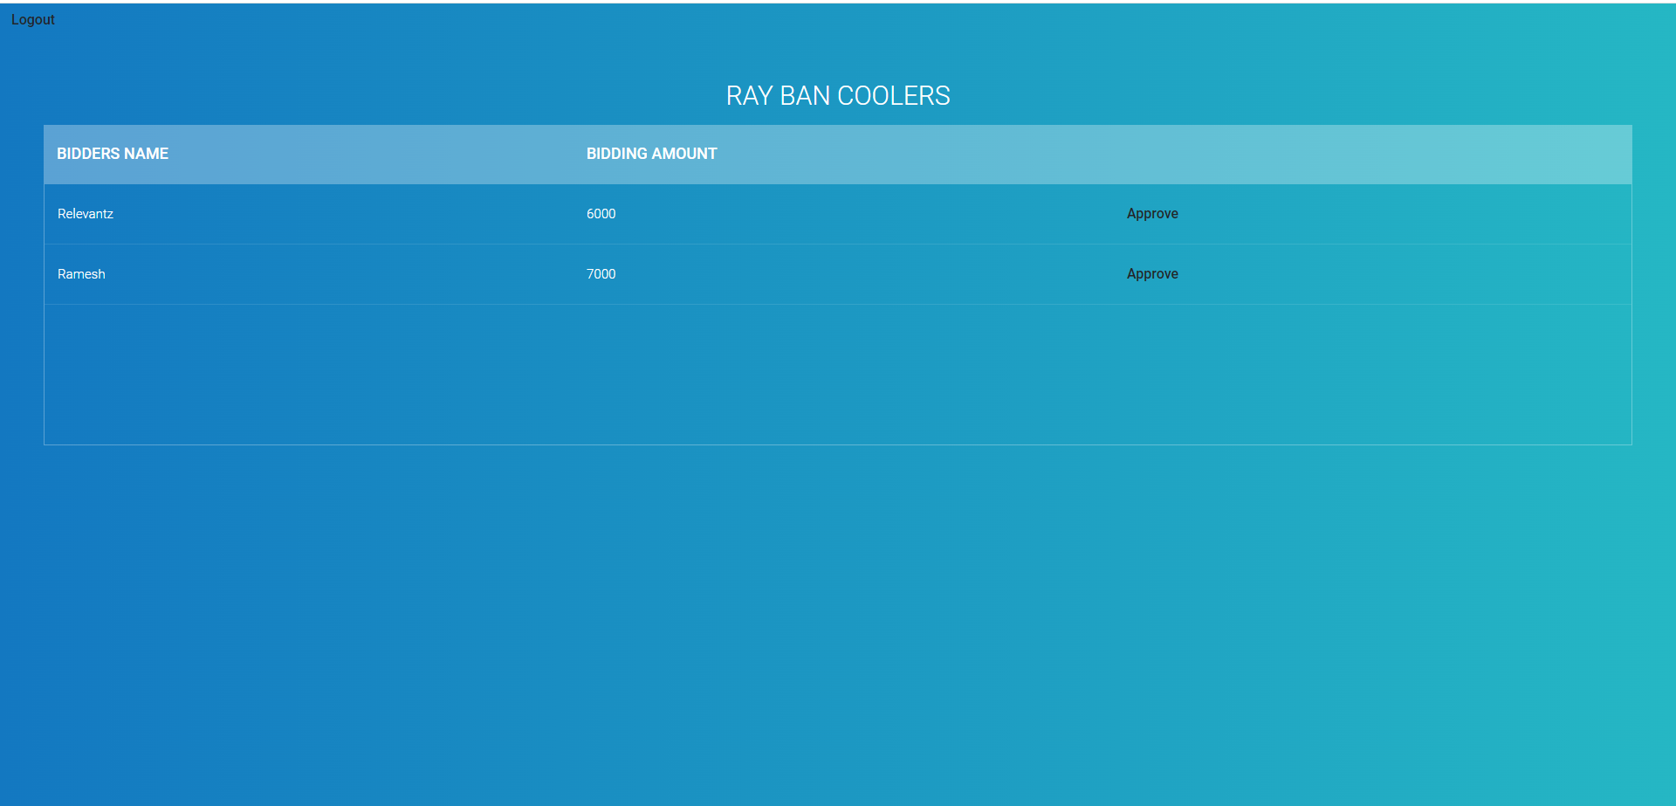

User with highest bid approved

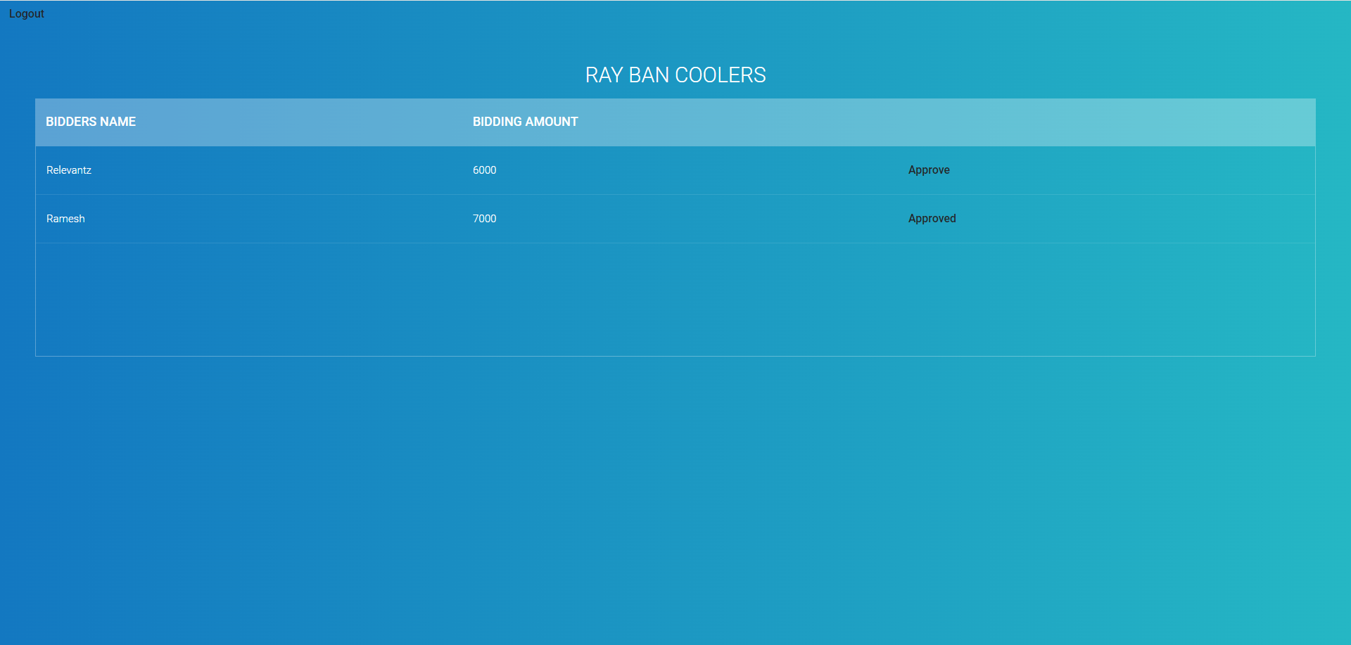

Product status after approval (Close)



Bidding status for the approved user (Buy Now)

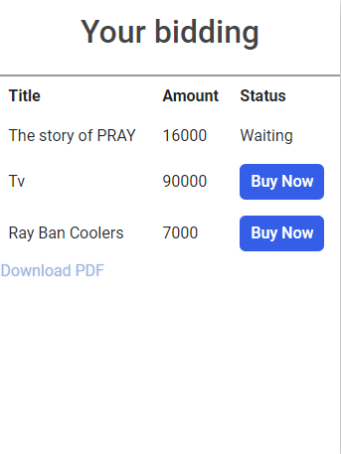

Bidding Status for the other user

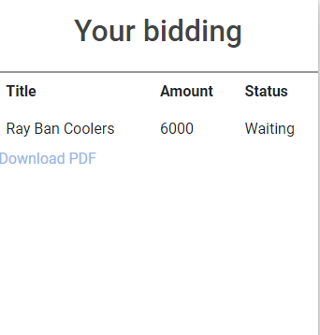

Payment page

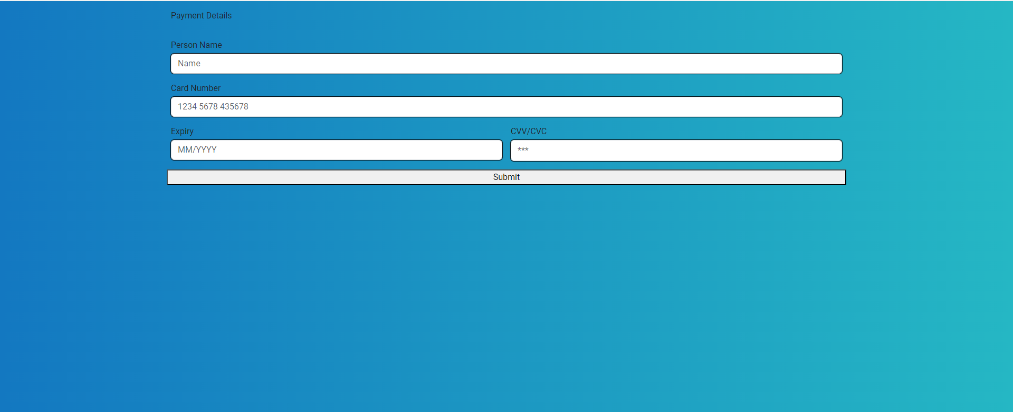

Code Quality:

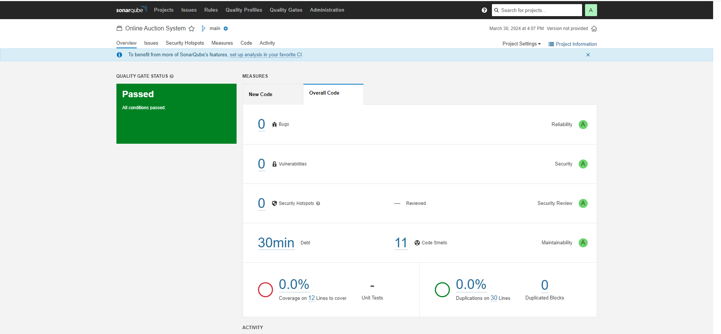

Reduced 2 code smell

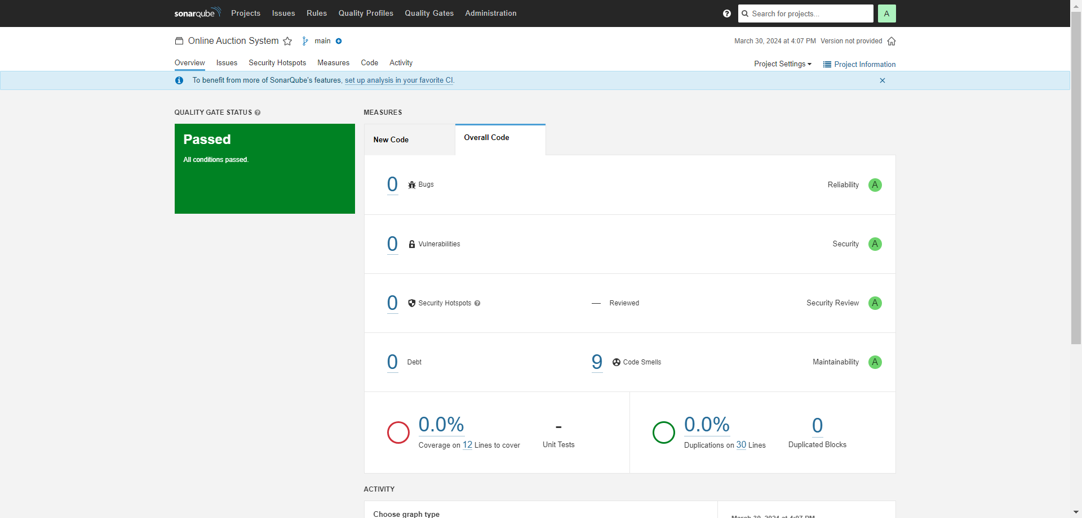

**Testing:**

Jest:

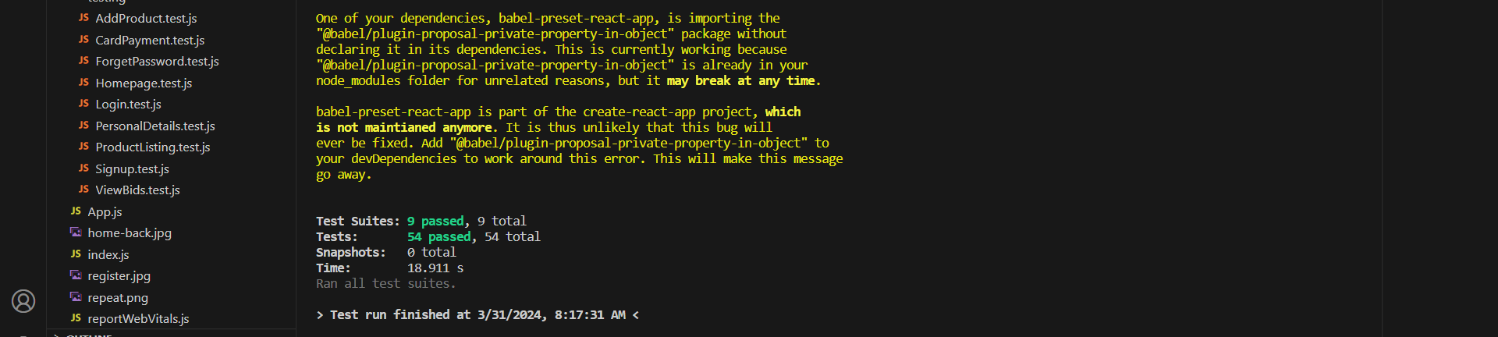

NUnit:

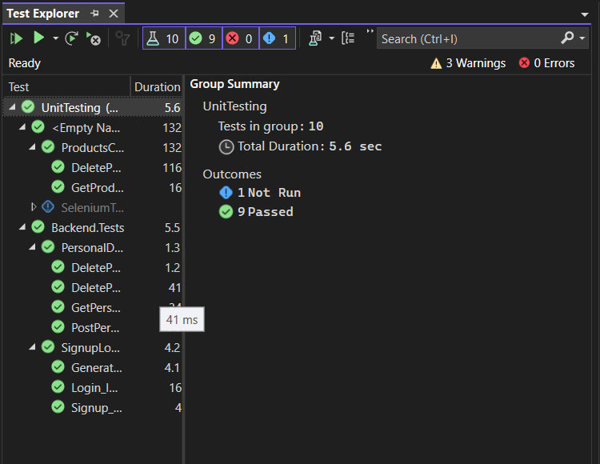

Selenium:

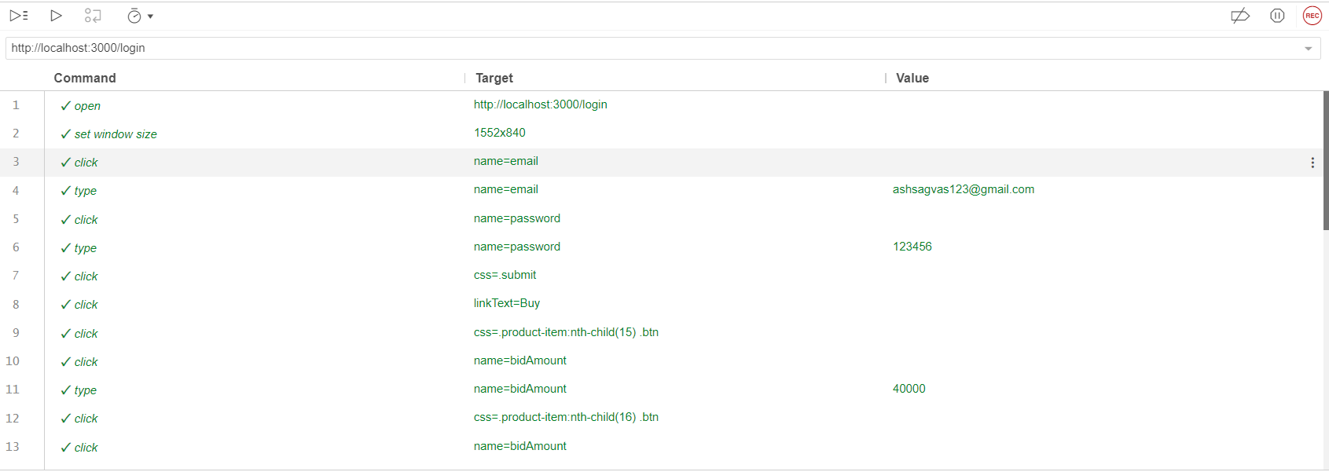

Docker Containers:

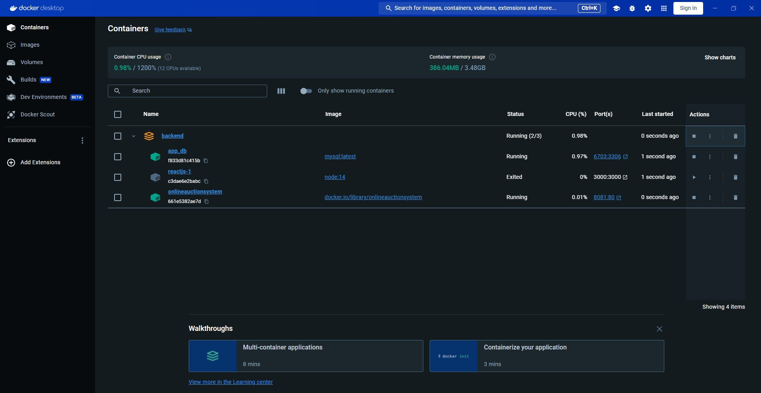

**Jenkins:**

Backend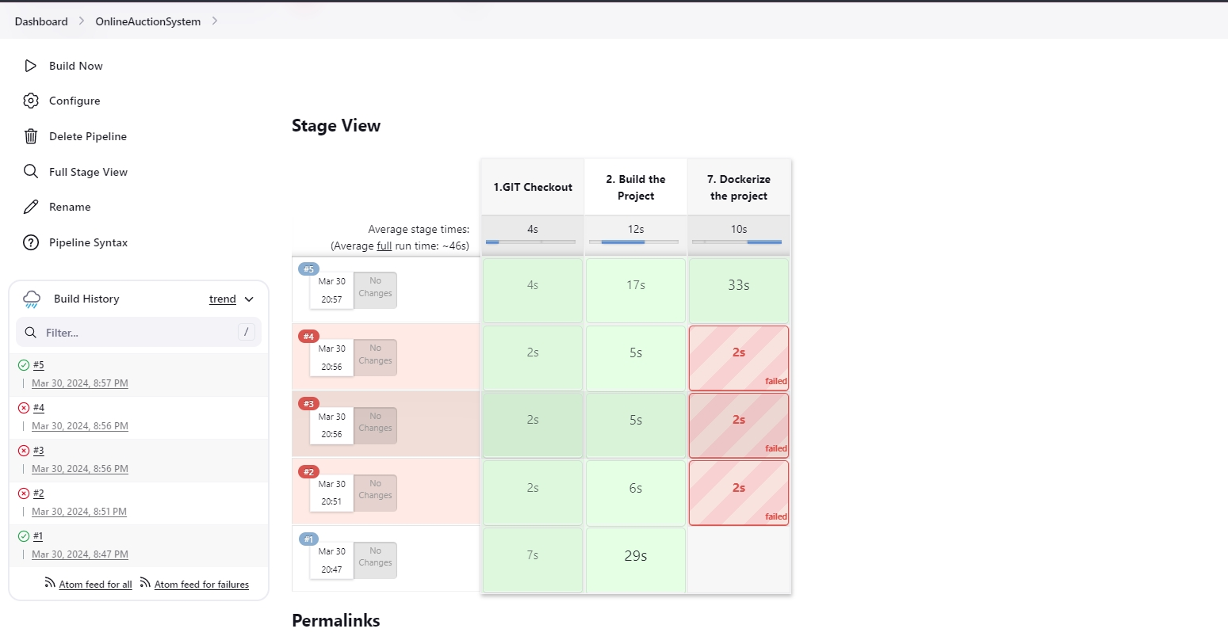

Frontend

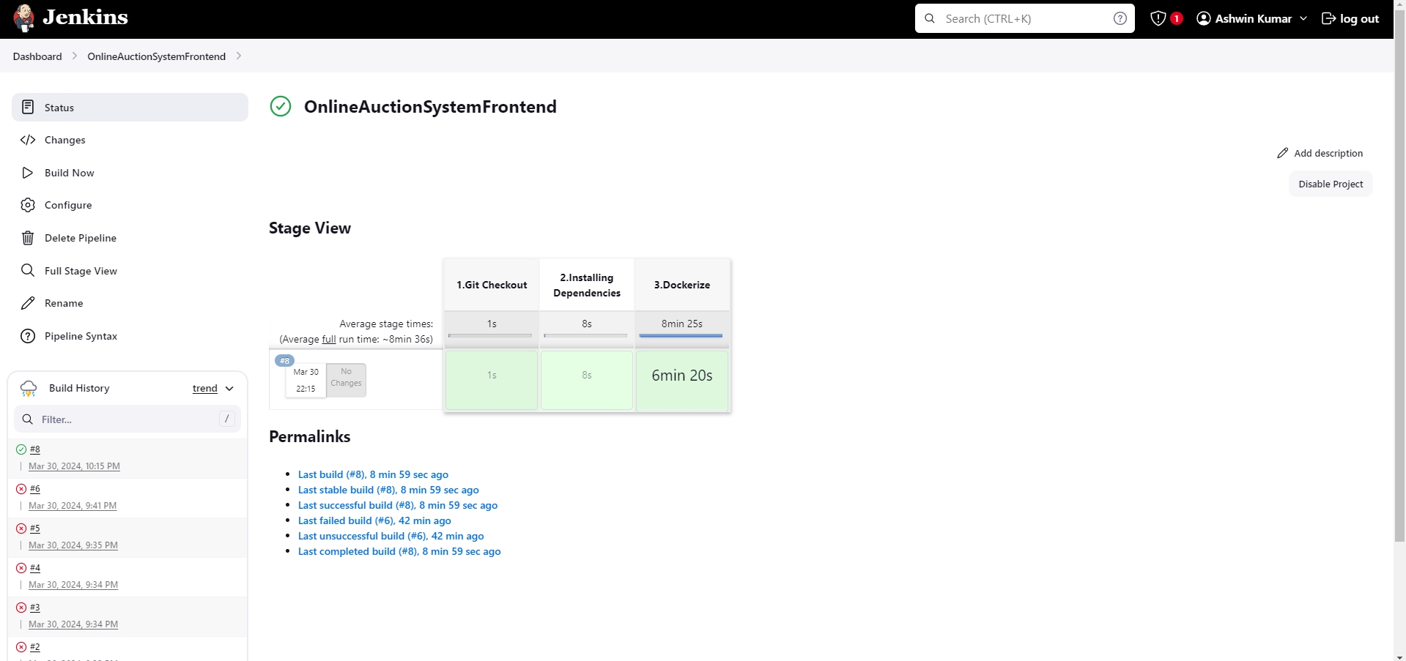

**Git Repository**

Backend:

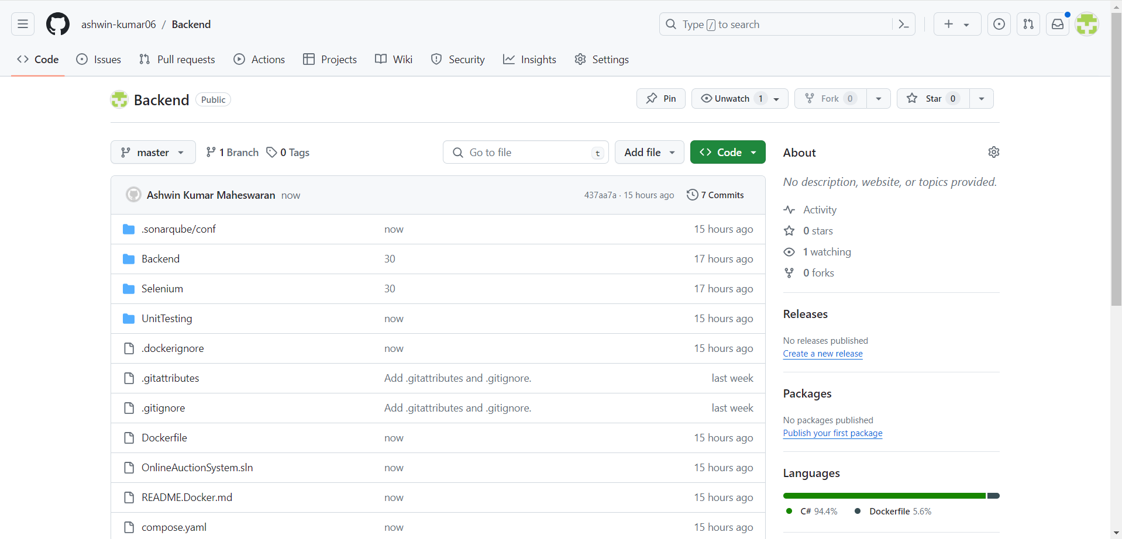

Frontend:

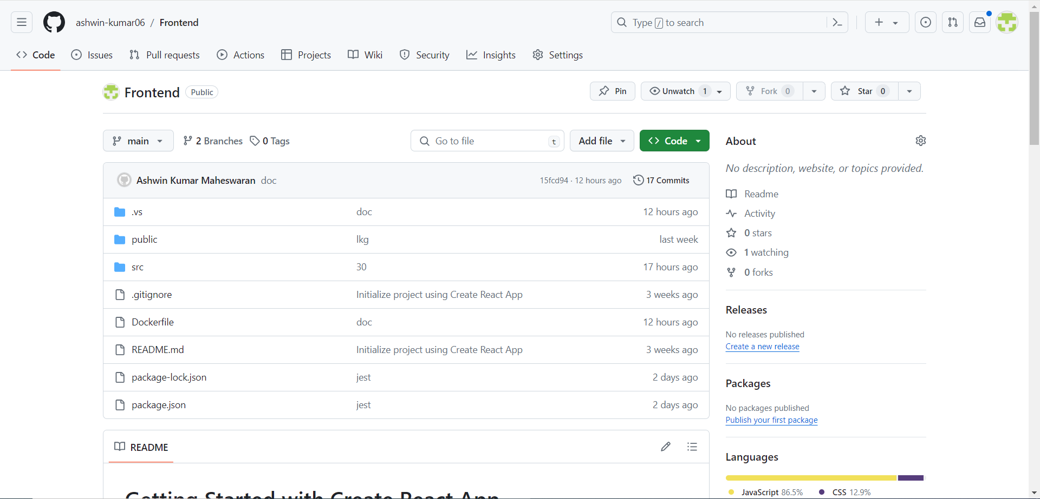

**Database**

User table:

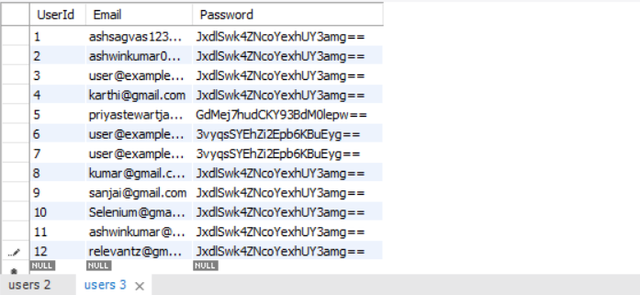

Personal details:

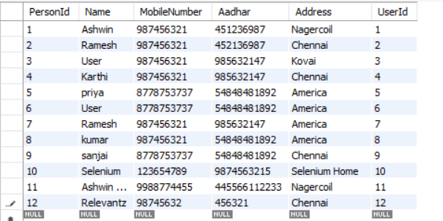

Products table:

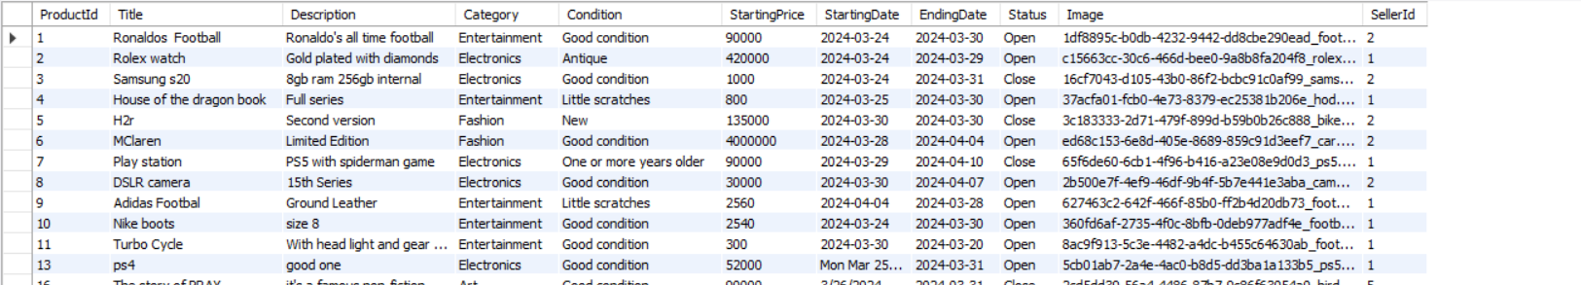

Bid table:

